

**CSC186 – OBJECT ORIENTED**

**PROGRAMMING**

**LAB ASSIGNMENT 3**

NAME : MUHAMMAD REDZA BIN MAHAYADIN

STUDENT ID : 2022676696

GROUP : RCDCS1102B

LECTURER : SIR MOHD NIZAM BIN OSMAN

QUESTION 3.1

SOURCE CODE 1.1 : CUPCAKE CLASS

public class Cupcake {

    private String name;

    private String code;

    private double price;

    public Cupcake() {

        name = "";

        code = "";

        price = 0;

    }

    public Cupcake(String name, String code, double price) {

        this.name = name;

        this.code = code;

        this.price = price;

    }

    public Cupcake(Cupcake cupcake) {

        this.name = cupcake.name;

        this.code = cupcake.code;

        this.price = cupcake.price;

    }

    public void setName(String name) {

        this.name = name;

    }

    public void setcode(String code) {

        this.code = code;

    }

    public void setPrice(double price) {

        this.price = price;

    }

    public String getName() {

        return this.name;

    }

    public String getCode() {

        return this.code;

    }

    public double getPrice() {

        return this.price;

    }

    public String toString() {

        return "Name: " + this.name + "\nCode: " + this.code + "\nPrice: " + this.price;

    }

    public double priceInDozen(String code) {

        int rate = 0;

        switch (code.charAt(code.length() - 1)) {

            case '1':

                rate = 5;

                break;

            case '2':

                rate = 8;

                break;

            case '3':

                rate = 10;

                break;

            default:

                System.out.println("Invalid code");

                break;

        }

        price = 12 * price * (1 - rate/100.0);

        return price;

    }

}

SOURCE CODE 1.2 : CUPCAKEAPP

import java.util.Scanner;

public class CupcakeApp {

    public static void main(String[] args) {

        Scanner in = new Scanner(System.in);

        System.out.print("Enter number of cupcakes: ");

        int size = in.nextInt();

        // Create an array of Cupcake objects

        Cupcake[] cupcake = new Cupcake[size];

        // Get data from user

        for (int i = 0; i < size; i++) {

            System.out.println("\nCupcake " + (i + 1));

            System.out.print("Enter name: ");

            String name = in.next();

            System.out.print("Enter code: ");

            String code = in.next();

            in.nextLine();

            System.out.print("Enter price: RM");

            double price = in.nextDouble();

            // Store data onto array

            cupcake[i] = new Cupcake(name, code, price);

        }

        in.close(); // Close scanner

        // Calculate and display price of cupcakes in dozens

        System.out.println("");

        for (int i = 0; i < size; i++) {

            System.out.printf("Price of %s in dozens: RM%.2f", cupcake[i].getName(), cupcake[i].priceInDozen(cupcake[i].getCode()));

            System.out.println("");

        }

        // Calculate and display price of all cupcakes

        double totalPrice = 0.0;

        for (int i = 0; i < size; i++) {

            totalPrice += cupcake[i].getPrice();

        }

        // Display total price

        System.out.printf("\nTotal price: RM%.2f\n", totalPrice);

    }

}

SAMPLE INPUT

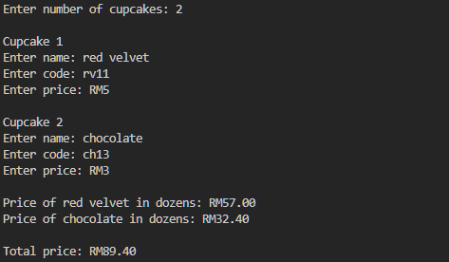

SAMPLE OUTPUT

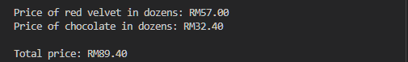

QUESTION 3.2

SOURCE CODE 2.1 : FRUIT CLASS

public class Fruit {

    private String name; // fruit name

    private String type; // local or imported

    private double weight; //in kg

    private double price; // per kg

    public Fruit() {

        this.name = "";

        this.type = "";

        this.weight = 0.0;

        this.price = 0.0;

    }

    public Fruit(String name, String type, double weight, double price) {

        this.name = name;

        this.type = type;

        this.weight = weight;

        this.price = price;

    }

    public Fruit(Fruit fruit) {

        this.name = fruit.name;

        this.type = fruit.type;

        this.weight = fruit.weight;

        this.price = fruit.price;

    }

    public void setName(String name) {

        this.name = name;

    }

    public void setType(String type) {

        this.type = type;

    }

    public void setWeight(double weight) {

        this.weight = weight;

    }

    public void setPrice(double price) {

        this.price = price;

    }

    public String getName() {

        return this.name;

    }

    public String getType() {

        return this.type;

    }

    public double getWeight() {

        return this.weight;

    }

    public double getPrice() {

        return this.price;

    }

    public boolean isLocal() {

        return type.equals("local");

    }

    public double calcTotalPrice() {

        double totalPrice = 0.0;

        if (isLocal()) {

            totalPrice = weight * price * 0.97; // 3% discount

        } else {

            totalPrice = weight * price;

        }

        return totalPrice;

    }

    public String toString() {

        return String.format("Fruit: %s\nType: %s\nWeight: %.2fkg\nPrice: RM%.2f\n", getName(), getType(), getWeight(), getPrice());

    }

}

SOURCE CODE 2.2 : FRUITAPP

import java.util.Scanner;

public class FruitApp {

    public static void main(String[] args) {

        //ask user for array size

        Scanner in = new Scanner(System.in);

        Scanner in1 = new Scanner(System.in);

        System.out.print("Enter the number of fruits: ");

        int size = in1.nextInt();

        Fruit[] fruitList = new Fruit[size];

        System.out.println();

        //input fruit information

        for (int i = 0; i < size; i++) {

            System.out.print("Enter the fruit name: ");

            String name = in.nextLine();

            System.out.print("Enter the fruit type (1-2). 1-Imported 2-Local : ");

            String type = in.nextLine();

            if (type.equals("1"))

                type = "imported";

            else

                type = "local";

            System.out.print("Enter the fruit weight (kg): ");

            double weight = in1.nextDouble();

            System.out.print("Enter the fruit price-per-kg: RM");

            double price = in1.nextDouble();

            //store data

            fruitList[i] = new Fruit(name, type, weight, price);

            System.out.println();

        }

        System.out.println("--------------------------------------------------\n"); //input output separator

        String highestPriceLocalFruitName = "";

        double highestPriceLocalFruitPrice = 0.0;

        double totalSaleImportedFruits = 0.0;

        for(int i = 0; i < size; i++){

            if (fruitList[i].isLocal()) { //local

                if (fruitList[i].getPrice() > highestPriceLocalFruitPrice) {  //find local fruit with highest price

                    highestPriceLocalFruitName = fruitList[i].getName();

                    highestPriceLocalFruitPrice = fruitList[i].getPrice();

                }

            }

            else { //imported

                totalSaleImportedFruits += fruitList[i].calcTotalPrice(); //accumulate total sale of imported fruits

            }

            System.out.println(fruitList[i]);

        }

        System.out.printf("Local fruit with highest price: %s (RM%.2f)", highestPriceLocalFruitName, highestPriceLocalFruitPrice);

        System.out.printf("%nTotal sale of imported fruits: RM%.2f%n", totalSaleImportedFruits);

        in.close();

        in1.close();

    }

}

SAMPLE INPUT

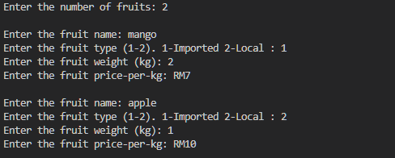

SAMPLE OUTPUT

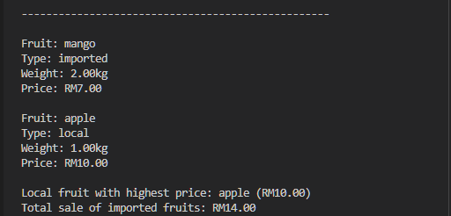

QUESTION 3.3

SOURCE CODE 3.1 : FURNITURE CLASS

public class Furniture {

    private String furnitureType;

    private String material;

    private double pricePerUnit;

    private int quantity;

    public Furniture() {

        this.furnitureType = "";

        this.material = "";

        this.pricePerUnit = 0.0;

        this.quantity = 0;

    }

    public Furniture(String furnitureType, String material, double pricePerUnit, int quantity) {

        this.furnitureType = furnitureType;

        this.material = material;

        this.pricePerUnit = pricePerUnit;

        this.quantity = quantity;

    }

    public Furniture(Furniture furniture) {

        this.furnitureType = furniture.furnitureType;

        this.material = furniture.material;

        this.pricePerUnit = furniture.pricePerUnit;

        this.quantity = furniture.quantity;

    }

    public void setFurnitureType(String furnitureType) {

        this.furnitureType = furnitureType;

    }

    public void setMaterial(String material) {

        this.material = material;

    }

    public void setPricePerUnit(double pricePerUnit) {

        this.pricePerUnit = pricePerUnit;

    }

    public void setQuantity(int quantity) {

        this.quantity = quantity;

    }

    public String getFurnitureType() {

        return furnitureType;

    }

    public String getMaterial() {

        return material;

    }

    public double getPricePerUnit() {

        return pricePerUnit;

    }

    public int getQuantity() {

        return quantity;

    }

    public String toString() {

        return String.format("%-15s: %s\n%-15s: %s\n%-15s: RM %.2f\n%-15s: %d", "Furniture Type", furnitureType,

                "Material", material, "Price Per Unit", pricePerUnit, "Quantity", quantity);

    }

    public double calcPriceFurniture() {

        double discountRate = 0.0;

        switch (material) {

            case "Wood":

                discountRate = 0.20;

                break;

            case "Rattan":

                discountRate = 0.15;

                break;

            case "Metal":

                discountRate = 0.10;

                break;

            case "Bamboo":

                discountRate = 0.05;

                break;

            default:

                discountRate = 0.0;

                break;

        }

        return (pricePerUnit * quantity) * (1 - discountRate);

    }

}

SOURCE CODE 3.2 : FURNITUREAPP

import java.util.Scanner;

public class FurnitureApp {

    public static void main(String[] args) {

        //ask user for array size

        Scanner in = new Scanner(System.in);

        Scanner in1 = new Scanner(System.in);

        System.out.print("Enter the amount of furniture: ");

        int size = in1.nextInt();

        Furniture[] furnitureList = new Furniture[size];

        System.out.println();

        for (int i = 0; i < size; i++) {

            System.out.print("Enter the furniture type: ");

            String furnitureType = in.nextLine();

            System.out.print("1. Wood\n2. Rattan\n3. Metal\n4. Bamboo\nEnter the material (1-4): ");

            String material = in.nextLine();

            switch (material) {

                case "1":

                    material = "Wood";

                    break;

                case "2":

                    material = "Rattan";

                    break;

                case "3":

                    material = "Metal";

                    break;

                case "4":

                    material = "Bamboo";

                    break;

            }

            System.out.print("Enter the price per unit: ");

            double pricePerUnit = in1.nextDouble();

            System.out.print("Enter the quantity: ");

            int quantity = in1.nextInt();

            //store data

            furnitureList[i] = new Furniture(furnitureType, material, pricePerUnit, quantity);

            System.out.println();

        }

        double totalWood = 0.0;

        double totalRattan = 0.0;

        double totalMetal = 0.0;

        double totalBamboo = 0.0;

        double highestPriceOfWoodFurniture = 0;

        for (int i = 0; i < size; i++) {

            if (furnitureList[i].getMaterial().equals("Wood")) { //accumulate prices of all materials

                totalWood += furnitureList[i].calcPriceFurniture();

            }

            else if (furnitureList[i].getMaterial().equals("Rattan")) {

                totalRattan += furnitureList[i].calcPriceFurniture();

            }

            else if (furnitureList[i].getMaterial().equals("Metal")) {

                totalMetal += furnitureList[i].calcPriceFurniture();

            }

            else if (furnitureList[i].getMaterial().equals("Bamboo")) {

                totalBamboo += furnitureList[i].calcPriceFurniture();

            }

        }

        for (int i = 0; i < size; i++) {

            if (furnitureList[i].getMaterial().equals("Wood") //find highest price of wood furniture

            && furnitureList[i].calcPriceFurniture() == highestPriceOfWoodFurniture) {

                highestPriceOfWoodFurniture = furnitureList[i].calcPriceFurniture();

            }

            System.out.println("-----------------------------------------\n"); //input output separator

            System.out.println(furnitureList[i].toString());//print furniture info

            System.out.println();

        }

        //output

        System.out.println("Total Price of Wood Furniture: RM " + totalWood +

                           "\nTotal Price of Rattan Furniture: RM " + totalRattan +

                           "\nTotal Price of Metal Furniture: RM " + totalMetal +

                           "\nTotal Price of Bamboo Furniture: RM " + totalBamboo +

                           "\nHighest Price of Wood Furniture: RM " + highestPriceOfWoodFurniture);

        in.close(); //close scanner

        in1.close();

    }

}

SAMPLE INPUT

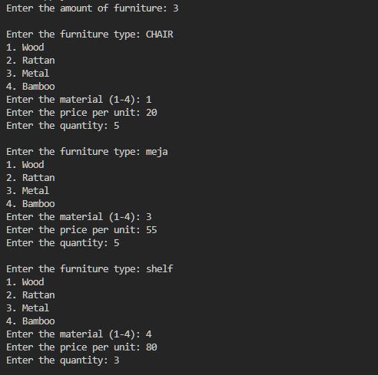

SAMPLE OUTPUT

